BANK LOAN REPORT QUERY DOCUMENT
- BANK LOAN REPORT | SUMMARY
KPI’s:
Total Loan Applications
Select count(id) as total_application
from project..bank_loan_data;
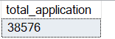
MTD Loan Applications
select count(*) as mtd_loan_application
from project..financialloandata
where month(issue_date) = 12;
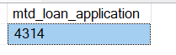
Total Funded Amount
Select sum(loan_amount) as total_loan_amount
From project..financialloandata;
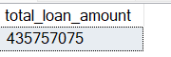

MTD Total Funded Amount
Select sum(loan_amount) as MTD_total_loan_amount
From project..financialloandata
Where month(issue_date) = 12;
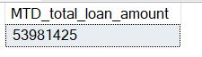
PMTD Total Funded Amount
select sum(loan_amount) as PMTD_total_loan_amount
from project..financialloandata
where month(issue_date) = 11;
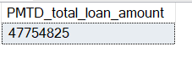
Total Amount Received
Select sum(total_payment) as total_amount_received
From project..financialloandata;
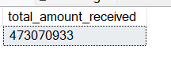

MTD Total Amount Received
Select sum(total_payment) as total_amount_received
From project..financialloandata
Where Month(issue_date) = 12;
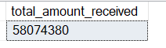

PMTD Total Amount Received
Select sum(total_payment) as total_amount_received
From project..financialloandata
Where Month(issue_date) = 11;
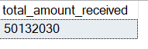

Average Interest Rate
Select Round(Avg(int_rate)*100,3) as Avg_Interest_Rate
From project..financialloandata;
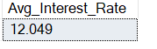

MTD Average Interest
Select Round(Avg(int_rate)*100,3) as Avg_Interest_Rate
From project..financialloandata
Where Month(issue_date) = 12;
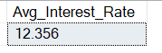

PMTD Average Interest
Select Round(Avg(int_rate)*100,3) as Avg_Interest_Rate
From project..financialloandata
Where Month(issue_date) = 11;
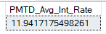

Avg DTI
SELECT Round(AVG(dti)*100,3) AS Avg_DTI
FROM project..financialloandata;
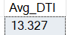
MTD Avg DTI
SELECT Round(AVG(dti)*100,3) AS MTD_Avg_DTI
FROM project..financialloandata
WHERE MONTH(issue_date) = 12;
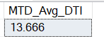
PMTD Avg DTI
SELECT Round(AVG(dti)*100,3) AS PMTD_Avg_DTI
FROM project..financialloandata
WHERE MONTH(issue_date) = 11;
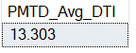

GOOD LOAN ISSUED
Good Loan Percentage
SELECT
ROUND(
(COUNT(CASE WHEN loan_status = 'Fully Paid' OR loan_status = 'Current' THEN id END)
* 100.0) / COUNT(id),3) AS good_loan_percentage
FROM project..financialloandata;
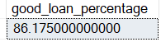

Good Loan Applications
Select count(*) as good_loan_application
From project..financialloandata
Where loan_status = 'Fully Paid' or loan_status = 'Current';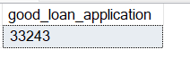
Good Loan Funded Amount
Select sum(loan_amount) as good_loan_amount
From project..financialloandata
Where loan_status = 'Fully Paid' or loan_status = 'Current';
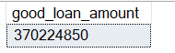

Good Loan Amount Received
Select sum(total_payment) as good_loan_amount_received
From project..financialloandata
Where loan_status = 'Fully Paid' or loan_status = 'Current';
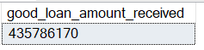

BAD LOAN ISSUED
Bad Loan Percentage
SELECT
(COUNT(CASE WHEN loan_status = 'Charged Off' THEN id END) * 100.0) /
COUNT(id) AS Bad_Loan_Percentage
From project..financialloandata
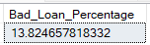
Bad Loan Applications
SELECT COUNT(id) AS Bad_Loan_Applications
From project..financialloandata
WHERE loan_status = 'Charged Off'
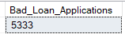
Bad Loan Funded Amount
SELECT SUM(loan_amount) AS Bad_Loan_Funded_amount
From project..financialloandata
WHERE loan_status = 'Charged Off'
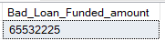
Bad Loan Amount Received
SELECT SUM(total_payment) AS Bad_Loan_amount_received
From project..financialloandata
WHERE loan_status = 'Charged Off'
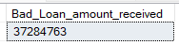

LOAN STATUS
Select loan_status,
count(loan_status) as total_loan_status,
sum(loan_amount) as total_loan_amount,
sum(total_payment) as total_amount_received,
Round(AVG(int_rate)*100,3) as AVG_interest_rate,
Round(AVG(dti)*100,3) as AVG_dti
From project..financialloandata
Group by loan_status;
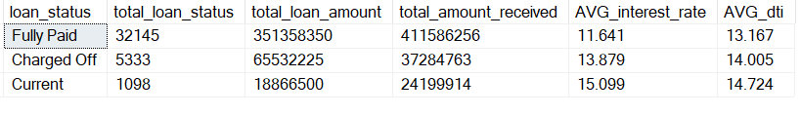
MTD Loan Status
Select loan_status,
count(loan_status) as total_loan_status,
sum(loan_amount) as total_loan_amount,
sum(total_payment) as total_amount_received,
Round(AVG(int_rate)*100,3) as AVG_interest_rate,
Round(AVG(dti)*100,3) as AVG_dti
From project..financialloandata
Where Month(issue_date) = 12
Group by loan_status;
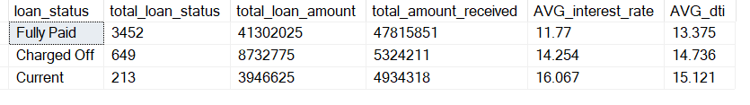
BANK LOAN REPORT | OVERVIEW
Select
Month(issue_date) as Month_Number,
DATENAME(Month,issue_date) as [Month],
count(id) as total_application,
sum(loan_amount) as Total_Loan_amount,
sum(total_payment) as Total_Amount_Received
From project..financialloandata
Group by Month(issue_date),DATENAME(Month,issue_date)
Order by Month(issue_date);
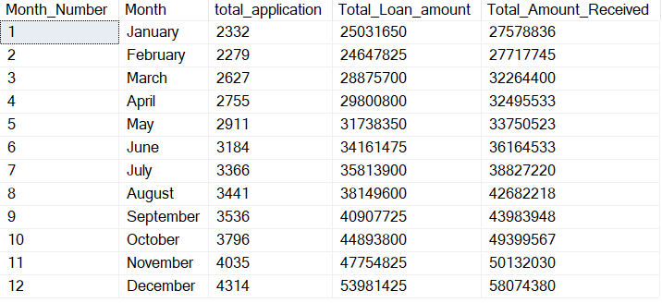

STATE
Select address_state,
count(id) as total_application,
sum(loan_amount) as Total_Loan_amount,
sum(total_payment) as Total_Amount_Received
From project..financialloandata
Group by address_state
Order by address_state;
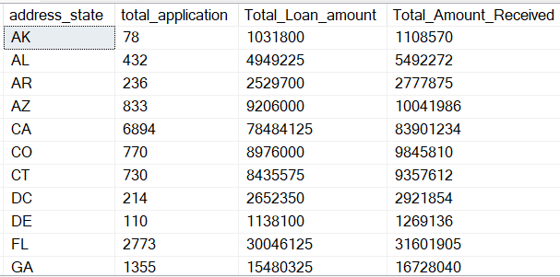

EMPLOYEE LENGTH
Select emp_length,
count(id) as total_application,
sum(loan_amount) as Total_Loan_amount,
sum(total_payment) as Total_Amount_Received
From project..financialloandata
Group by emp_length
Order by emp_length;
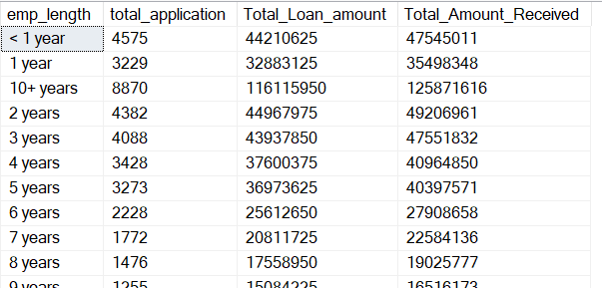

PURPOSE
Select purpose,
count(id) as total_application,
sum(loan_amount) as Total_Loan_amount,
sum(total_payment) as Total_Amount_Received
From project..financialloandata
Group by purpose
Order by purpose;
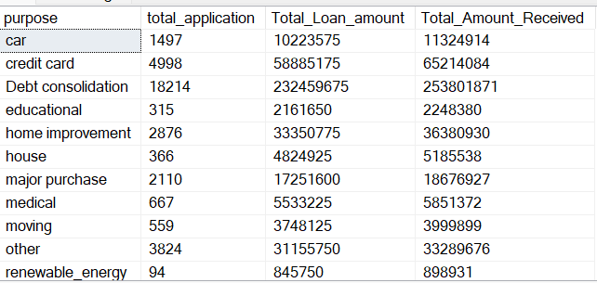

HOME OWNERSHIP
Select home_ownership,
count(id) as total_application,
sum(loan_amount) as Total_Loan_amount,
sum(total_payment) as Total_Amount_Received
From project..financialloandata
Group by home_ownership
Order by home_ownership;
